**Java Assignment-5**

**Name:** Kaustubh N. Kulkarni **Div:** A

**Roll no**: 1911027

**-------------------------------------------------------------------------------------------------------**

**/\*\***

* Q1) Write a program on Java ArrayList add() Method which is used for adding an element to the specified index.

* */

import java.util.ArrayList;

public class addArray {

public static void main(String[] args) {

ArrayList<String> fruits = new ArrayList<String>();

fruits.add("Mango");

fruits.add("Orange");

System.out.println("Fruits :");

for (String fruit : fruits) {

System.out.println(fruit);

}

fruits.add(1,"Apple");

System.out.println("\nFruits:" + fruits);

}

}

**Output:**

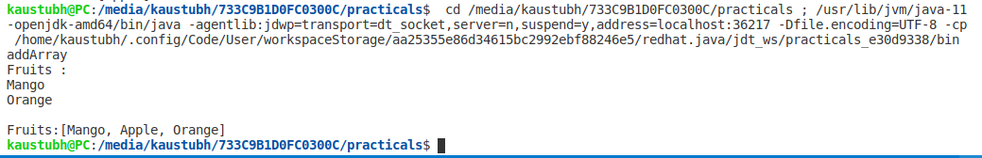

/**

* Q2 ) Write a program to remove an element of the specified index from a list

*/

import java.util.*;

public class removeArray {

public static void main(String[] args) {

List<String> fruits = new ArrayList<String>(5);

fruits.add("Apple");

fruits.add("Gauva");

System.out.println("Fruits :" + fruits);

fruits.remove(1);

System.out.println("Final List :" + fruits);

}

}

**Output:**

